How to copy NEBS data for Cost Allocation:
(Note: Fund Mapping needs to be complete for Base and all decision units prior to using mapping in NEBS.)

1) Log in to NEBS
2) Select “NEBS” tab
3) Select Budget Period
4) Select Budget Account
5) Select Budget Version
6) Click on the Mapping tab

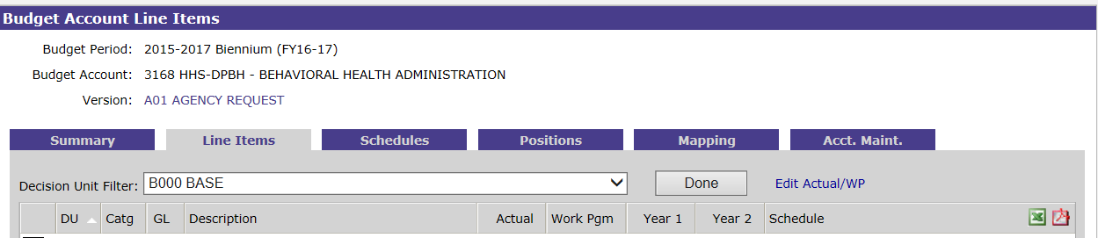

7) Select Year (Year 1, then Year 2)

8) Select Summary

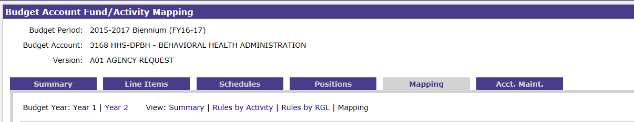

9) Select “Funding (DU)” from the Summary Mapping View by: drop down list

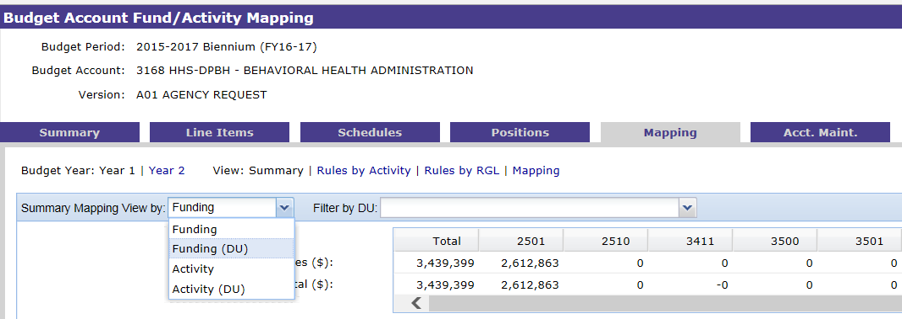

Your screen should look similar to the picture below.
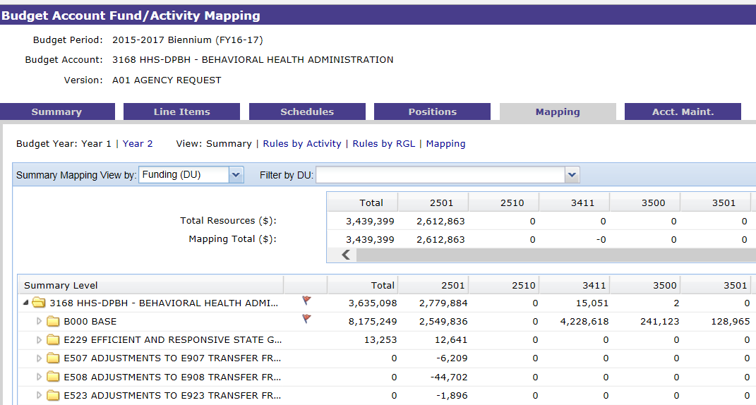

10) Open a blank Excel document.

11) Navigate back to the NEBS screen. Click anywhere within the NEBS screen. To copy of the fund map from NEBS into Excel hold down your “Ctrl” button and click “A”. This will highlight your entire NEBS screen as shown below.

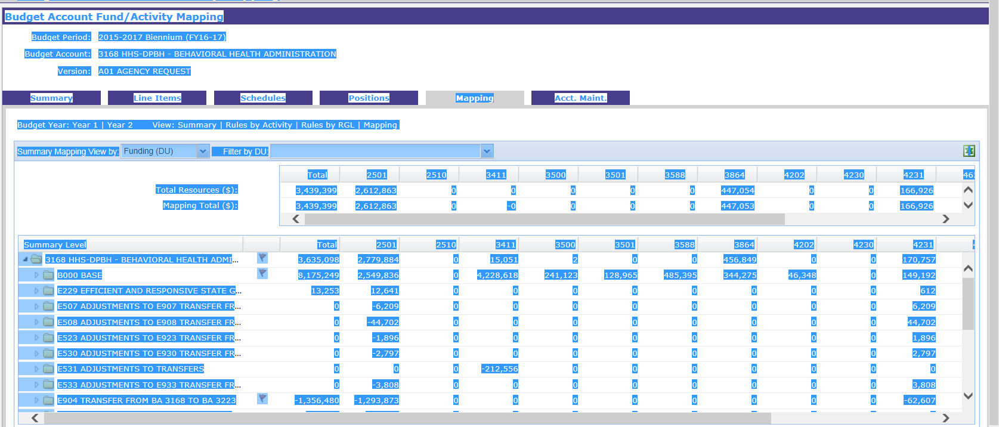

12) Hold down you “Ctrl” button and click “C”.

13) Navigate back to your blank Excel document screen. Click in Cell A1. With your cursor in cell A1 right-click your mouse and under Paste Options, choose “match destination formatting”.

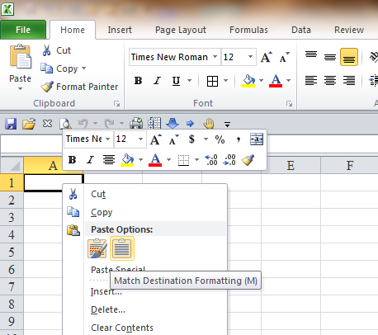

Your excel spreadsheet should look similar to the picture below.

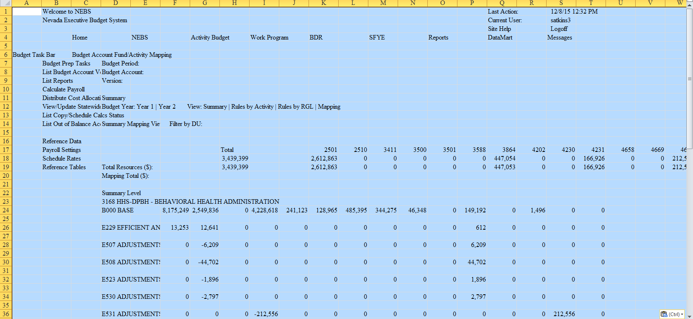

Now the excel spreadsheet needs to be cleaned up.

Cut and paste the Budget Period, Budget Account, Version, Budget Year, and Last Action in Cell D80 or below.

14) Delete rows 1 through the row directly above the words “Summary Level” by left clicking on Row 1 and highlighting all rows up to and including the row located directly above the words “Summary Level” as shown below.

15) Make sure your cursor is positioned directly over the last highlighted row, right click and choose delete.

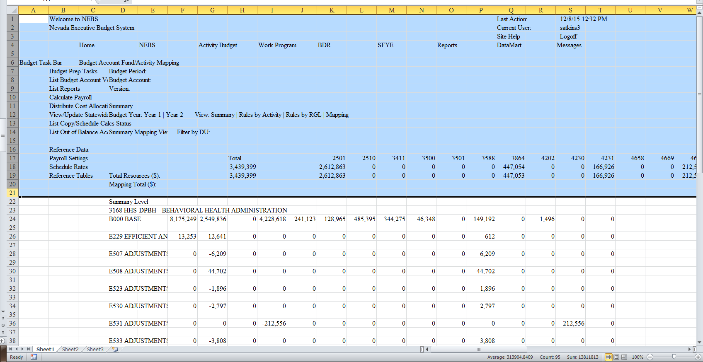

16) Next delete columns A through C by clicking on column A and dragging your mouse so that it highlights all three columns as shown below.

17) Make sure your cursor is positioned directly over the highlighted column letters A, B, or C, right click and choose delete.

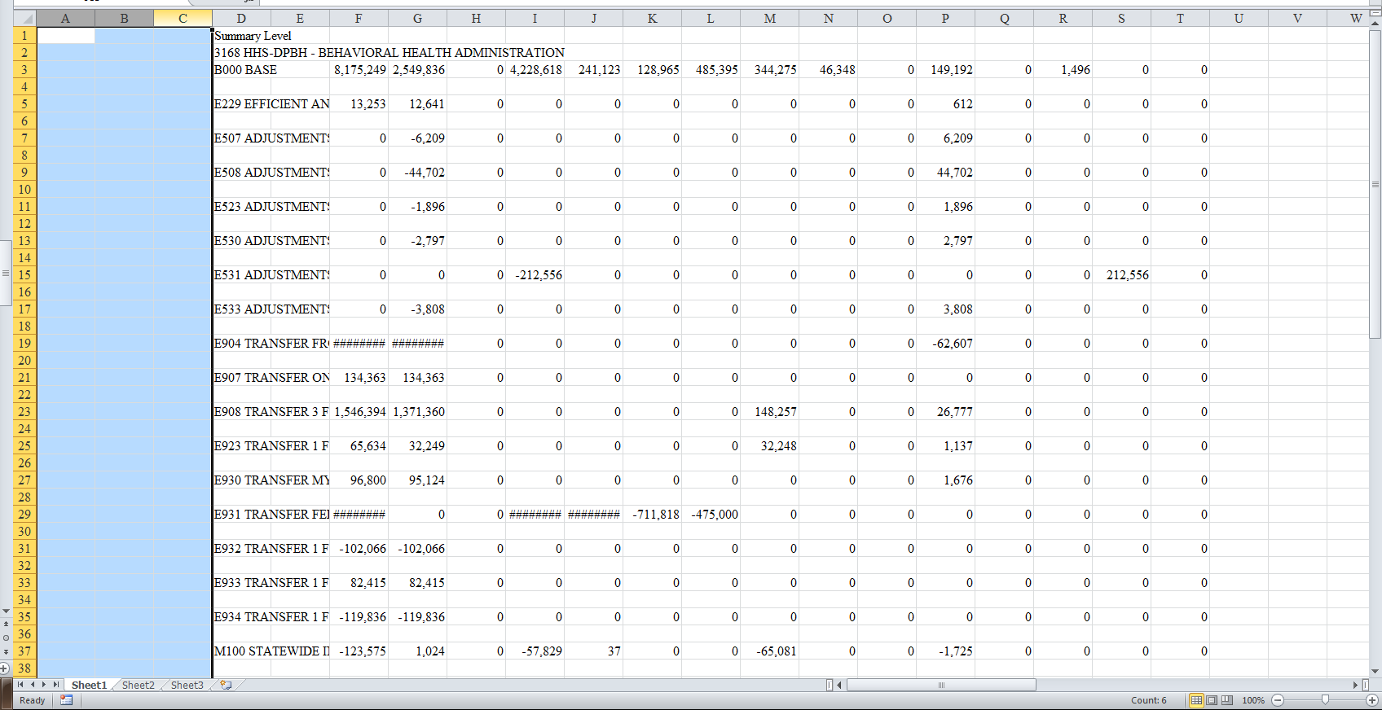

18) Select Rows 3 through 6, right click on the highlighted area, and choose insert.

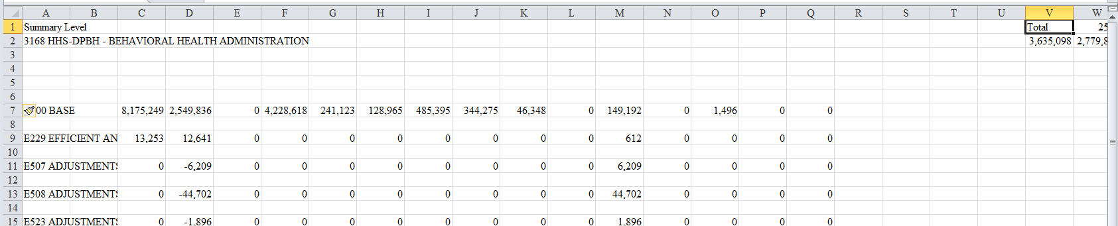

19) Next, highlight the revenue headers and totals located to the far right in rows 1 and 2.

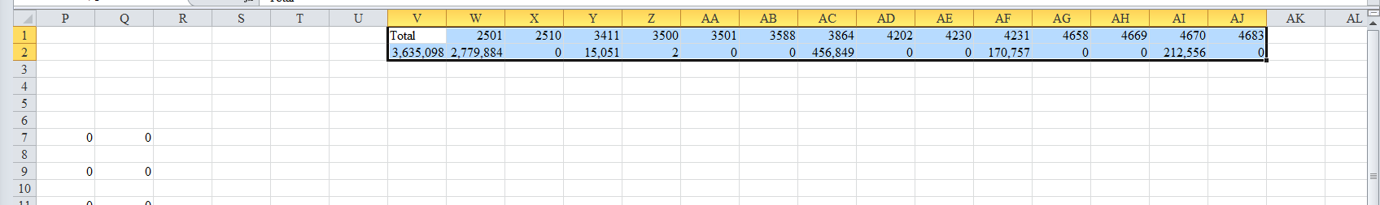

20) With your cursor positioned over the highlighted cells, right click and choose “cut”.

21) Click in Cell C4, then right click and choose paste. Your revenue totals should be located directly over the expenditures lines as shown below.

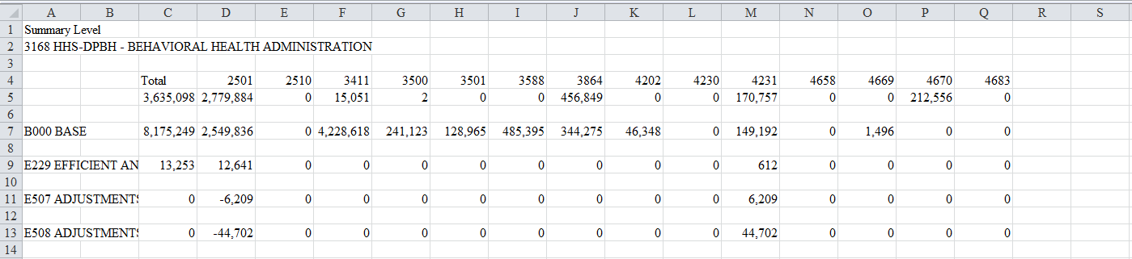

22) Add “Revenue:” label in Cell A5

23) Highlight and delete all blank rows starting under B000 so it will condense the spreadsheet.

24) Highlight and select all rows starting from NONE (located below all the decision units) and continuing down the spreadsheet until five rows before the Budget Period row.

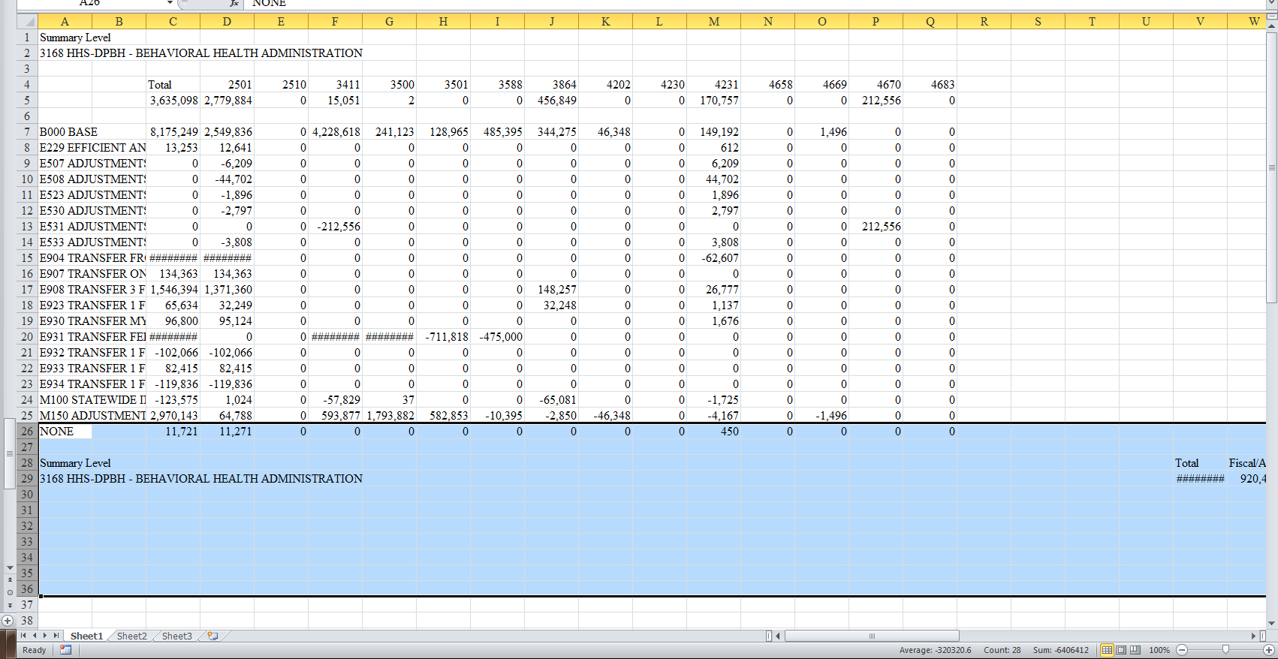
25) Subtotal deck unit B000 through last deck unit at the bottom of each column. Do not include the Revenue row total in the subtotal. Your spreadsheet should look like the example below.

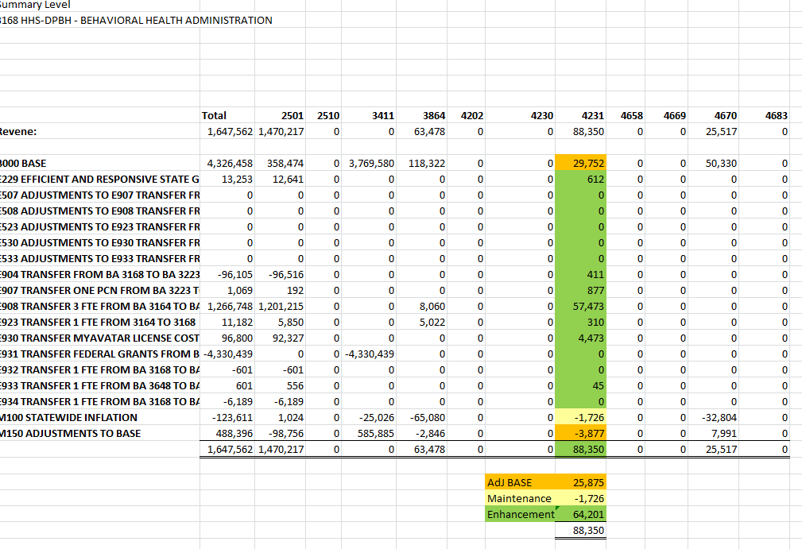
26) Then, subtotal the decision units and group into Adjusted BASE, Maintenance and Enhancements as shown above.

Adjusted BASE = BASE, M150
Maintenance = M decision units except M150
Enhancement = E decision units

27) Save and close the file
28) Repeat from Step 7 for Year 2

